**Pricing and Calibration API**

* **Description:**

The Pricing and Calibration api is used to trigger the Pricing and Calibration code.

This code mainly used to generate the pricing of the **Revseed** hotels.

The links for calling these api’s are given below and are required to be added on Revseed as shown below screenshot.

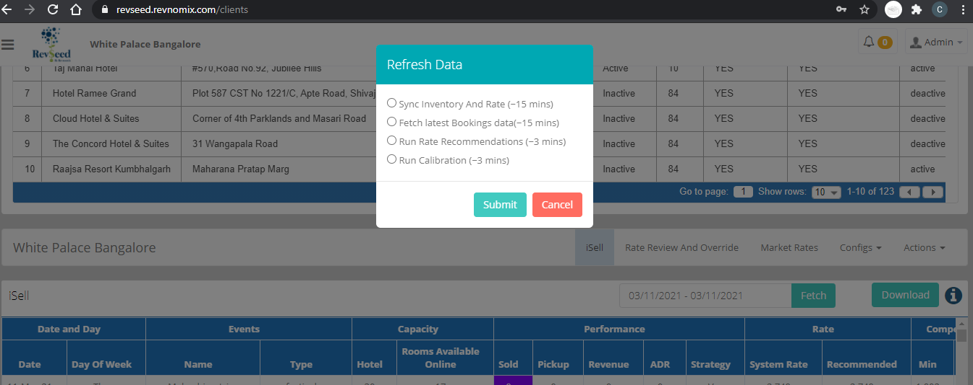

* **Api Links**:

**Home**: <http://13.232.233.63:5000/>

**Recommendation**: <http://13.232.233.63:5000/api/recommendation/id>

**Calibration:** [http://13.232.233.63:5000//api/calibration/id](http://localhost:5000/api/calibration/id)

* **Methods:**

**Home**: GET

**Recommendation:** POST

**Calibration:** POST

* **Output:**

1. **Home:**

* Test**:**

{

    "name": "Pricing Recommendation and Calibration api",

    "api-version": "v.0.0.1"

}

1. **Recommendation**:

* Success:

{

    "message": "Recommendation run successfully .....",

    "pid": 3,

    "status": {

        "Recommendation": {

            "massage": "Success",

            "days": 6

        },

        "rate_push": "Upload completed for clientId: 44 with status code: 200"

    }

}

* Failed:

{

    "message": "Recommendation run successfully .....",

    "pid": 44,

    "status": {

        "Recommendation": "Failed",

        "rate_push": "rate push disable"

    }

}

1. **Calibration:**

* Success:

{

    "message": "Calibration run successfully .....",

    "pid": 3,

    "status": {

        "Calibration": " Success "

    }

}

* Failed:

{

    "message": "Calibration run successfully .....",

    "pid": 3,

    "status": {

        "Calibration": "Failed"

    }

}